**DAILY ONLINE ACTIVITIES SUMMARY**

|  |  |  |  |  |  |  |  |
| --- | --- | --- | --- | --- | --- | --- | --- |
| **Date:** | **20/06/2020** | | | | **Name:** | **Syed Rabeya Aamir** | |
| **Sem & Sec** | **8th B** | | | | **USN:** | **4AL16CS112** | |
| Online Test Summary | | | | | | | |
| **Subject** | | **__** | | | | | |
| **Max. Marks** | | **__** | | **Score** | | **__** | |
| Certification Course Summary | | | | | | | |
| **Course** | **AWS SECURITY FUNDAMENTAL.** | | | | | | |
| **Certificate Provider** | | | **Aws** | **Duration** | | | **2 hrs** |
| Coding Challenges | | | | | | | |
| **Problem Statement:**  **1)** Python program for reversal algorithm of array rotation. | | | | | | | |
| **Status: Solved** | | | | | | | |
| **Uploaded the report in Github** | | | | **YES** | | | |
| **If yes Repository name** | | | | **rabeya** | | | |
| **Uploaded the report in slack** | | | | **YES** | | | |

**Certification Course Details:**

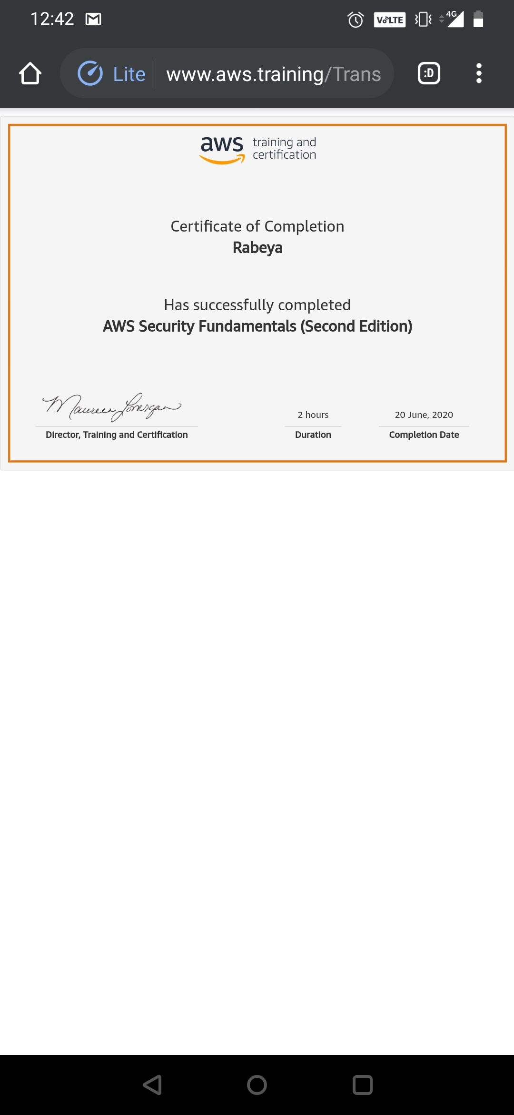

# CODE:

Program no:1

# Python program for reversal algorithm of array rotation

# Function to reverse arr[] from index start to end

def rverseArray(arr, start, end):

while (start < end):

temp = arr[start]

arr[start] = arr[end]

arr[end] = temp

start += 1

end = end-1

# Function to left rotate arr[] of size n by d

def leftRotate(arr, d):

n = len(arr)

rverseArray(arr, 0, d-1)

rverseArray(arr, d, n-1)

rverseArray(arr, 0, n-1)

# Function to print an array

def printArray(arr):

for i in range(0, len(arr)):

print (arr[i])

# Driver function to test above functions

arr = [1, 2, 3, 4, 5, 6, 7]

leftRotate(arr, 2) # Rotate array by 2

printArray(arr)